

Dear Supporter,

Thank you for supporting our fundraising by collecting used postage stamps. Contrary to what most people think, older stamps (pre 2008) are almost never valuable, the charity gets most return from modern stamps – the ones with security tabs. Please try to minimise the amount of paper/card attached to the stamp, a good guide is to have a finger’s width (or 1cm) of paper all the way around. Here are some examples -

USABLE UNUSABLE

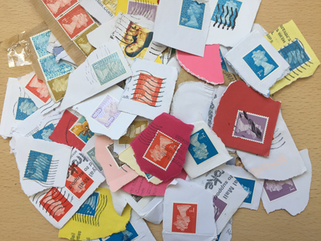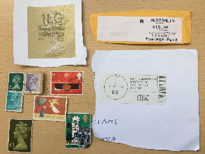

Please do not put in any pre-printed postage such as the large gold labels

Please separate the stamps into British/Foreign, Channel Island and Isle of Man count as foreign. No other sorting is necessary. Please pack the envelope as evenly as possible and try not to over fill it, there is no rush to get the stamps into us so please hold onto the envelope until you feel that it is sufficiently filled.

We would like to thank you for your donation and send you a replacement envelope, if you would like one please fill out the simple form below, if you would like more than one for yourself, family or friends please let us know. You can also request a small display collection box; it’s suitable for reception areas, staffrooms, offices and the like and is a visible reminder of the stamp scheme. We also now are able to take donations of foreign coins and would be very grateful if you would choose to collect them for us. If you do, please tick the relevant box below and we will send you a Coin Pack!

Please note: your personal details are never passed on to any third parties.

Money raised will go to ACN’s #RedWednesday Appeal fund to help persecuted Christian communities around the world. See www.acnuk.org/redwednesday

Thank you for your donation!
-------------------------------------------------------------------------------------------------------------------------
From: …………………………………………………….. (first/last name)

Address: ………………………………………………………..

………………………………………………………….

………………………………………………………….

Postcode: ……………………………… Email: …………………………………………………………………………

Materials available to order -

Prepaid envelopes Coin Pack Display Collection Box

