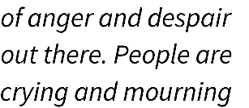
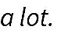
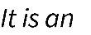
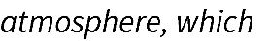
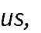
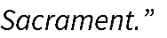
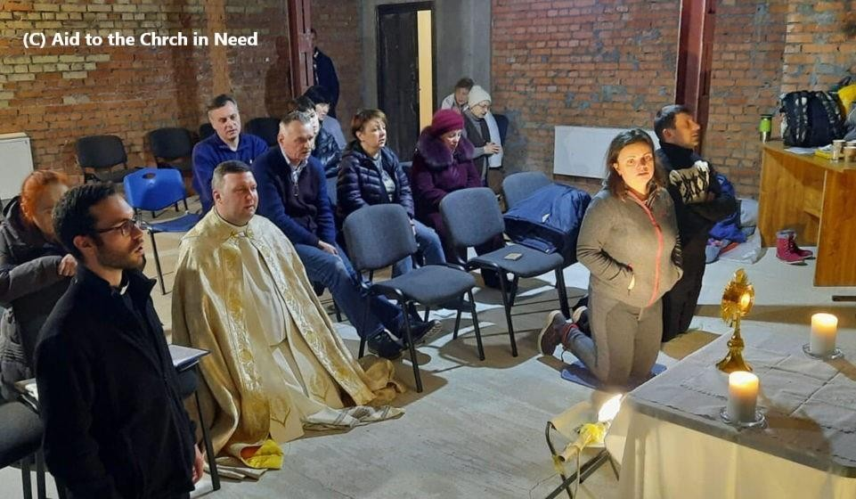
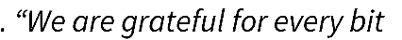

Aid to the Church in Need – Parish Holy Hour for Peace in Ukraine

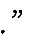

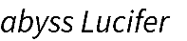

Aid to the Church in Need | Prayer & Fasting for Ukraine (Primary) (acnuk.org)

Aid to the Church in Need (ACN) is a Pontifical Foundation of the Catholic Church, supporting the Catholic faithful and other Christians where they are persecuted, oppressed or in pastoral need.
Founded on Christmas Day 1947, ACN supports around 5,000 projects across the world each year.
For regular updates from the suffering Church around the world or to find out more information, please visit www.acnuk.org

Thank you for your prayers and support for our brothers and sisters in Christ in Ukraine.
’
’
7

