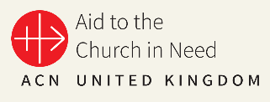
Aid to the Church in Need
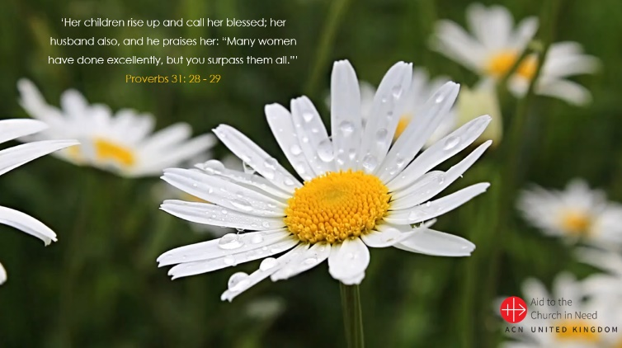
Mother’s Day 2023 – Support Document
‘Her children rise up and call her blessed; her husband also, and he praises her: “Many women have done excellently, but you surpass them all.”’
Proverbs 31: 28 - 29
PowerPoint/Resource Overview
This year’s ‘Mother’s Day’ resource is entitled ‘ACN Celebrates ‘All’ Mother’s Day’ as we encourage our children/young people to think about mothers and their families throughout the world, particularly those supported by Aid to the Church in Need, with a particular focus on current projects in Kazakhstan and Ukraine.
The PowerPoint incorporates an opportunity for prayer and reflection (based on the story of The Annunciation, highlighting the importance of Mary in the Catholic faith) and concludes with a ’call to action’ whereby the children are encouraged to ‘Celebrate ‘All’ Mother’s Day’ in various ways, including through donating the cost of a Mother’s Day card to support various ACN projects as featured in the presentation.
Slides 1 – 5: General Introduction
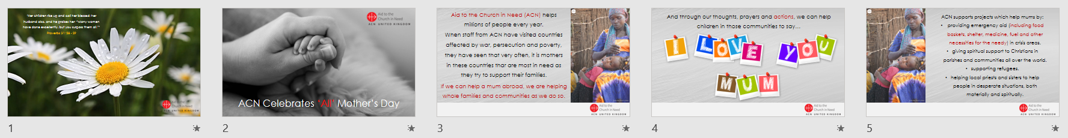
- Slides 1 - 2: Opening Slide (looped video) - appropriate music could be used here as pupils gather/prepare.
- Slides 3 - 4: Introduction to Aid to the Church in Need (ACN) and the ‘Mother’s Day’ focus of the presentation.
- Slide 5: Outlines the various ways in which ACN supports different communities throughout the world, including mothers.

Slides 6 - 10: Focus on Mary, the mother of Jesus
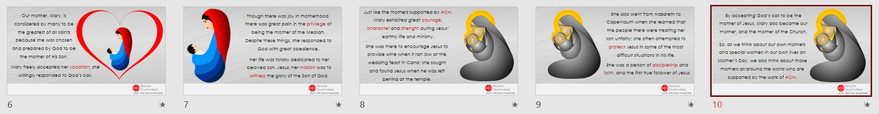
- Slides 6 - 7: Describe Mary’s response to God’s call to be the mother of His Son and her subsequent dedication to/love for Jesus.
- Slides – 8 - 9: Outline some of Mary’s characteristics as the first ‘true follower of Jesus’; includes some events/Bible passages that children may be familiar with.
- Slide 10: Makes the link between Mary and the mothers/communities that ACN supports.
Slides 11 - 15: Focus on Mothers supported in Kazakhstan and Ukraine
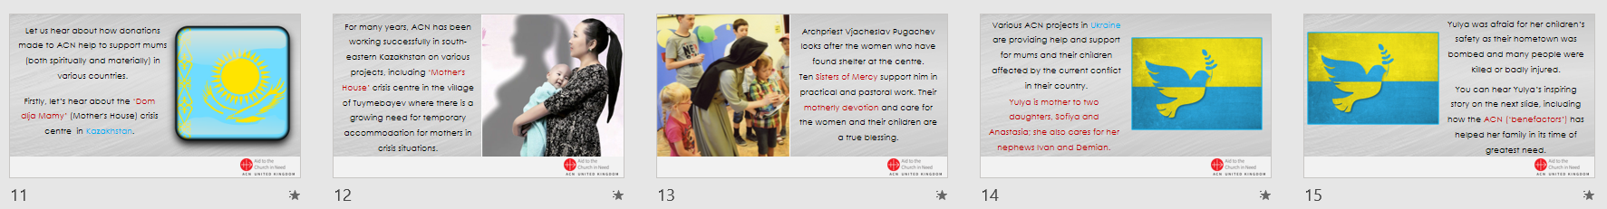
- Slides 11 - 13: Focus on the ‘Dom dlja Mamy’ (Mother's House) crisis centre in Kazakhstan and the work of the Sisters of Mercy.
- Slides 14 - 16: Focus on Yulya (from Ukraine) her two daughters, Sofiya and Anastasia and a her nephews Ivan and Demian that she also cares for. Slide 16 is a subtitled video clip in which Yulya describes how she has been helped by ACN/the local Catholic community/church.
Slides 17 - 30: Prayer and Liturgy
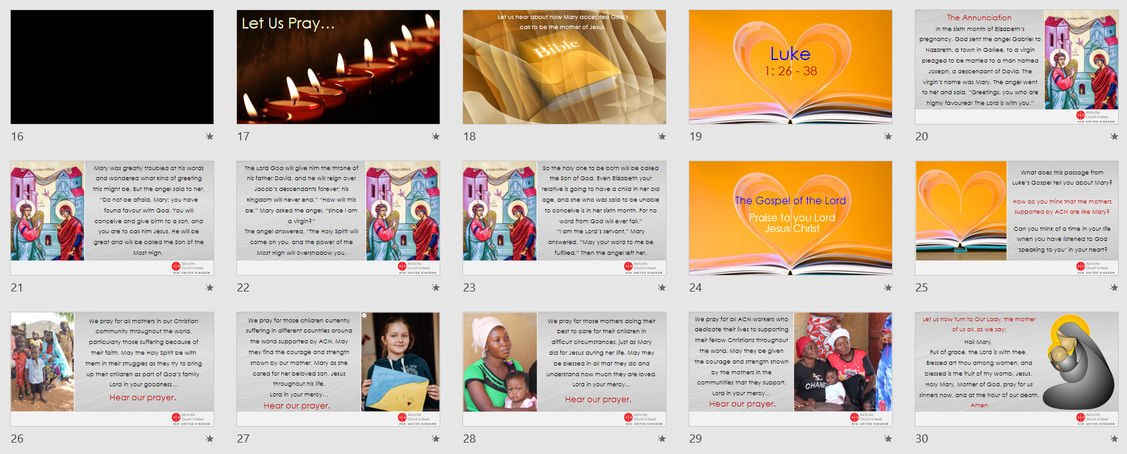
- Slides 17 - 24: Introduction/Gospel reading: The Annunciation (Luke 1: 26 – 38)
- Slide 25: Reflection/Discussion slide based on Luke 1: 26 - 38; this can be used, adapted or removed as required.
- 26 - 30: Prayers of the Faithful – these can be adapted as required; opportunities for spontaneous prayer could also be included; Hail Mary.
Slides 31 - 39: What Can I Do? - Call to Action.
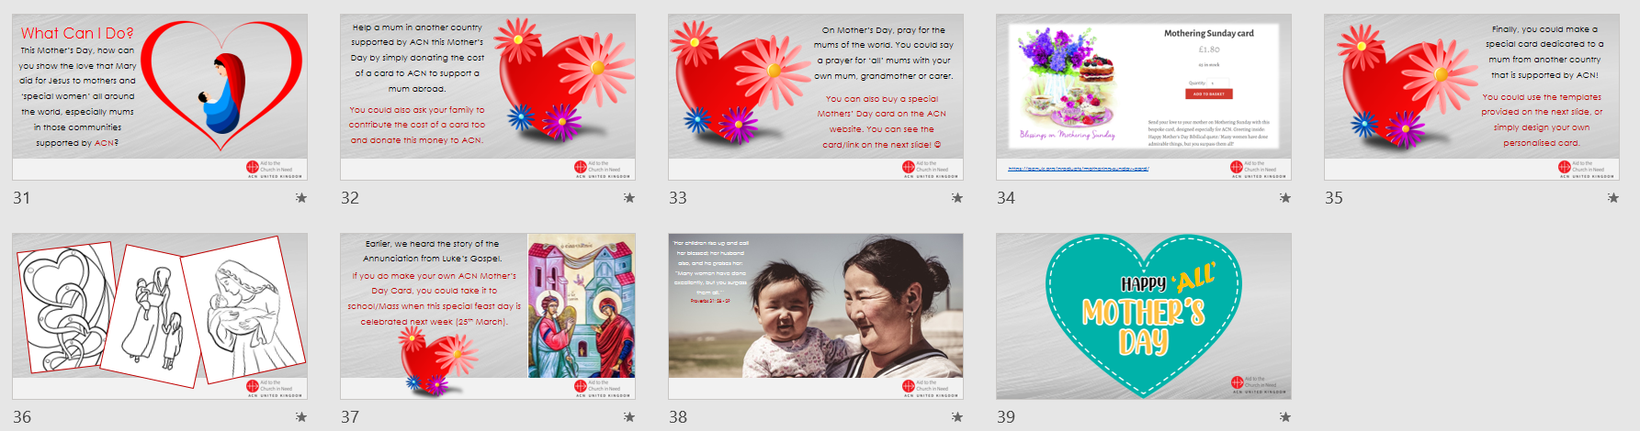
- Slides 31 - 35: ‘What Can I Do?’ – Ideas for various ways that children can demonstrate their support for mothers in communities supported by ACN; slide 34 provides a link to a Mother’s Day card that can be purchased on the ACN website: https://acnuk.org/products/mothering-sunday-card/
- Slide 36: Possible templates to use for children to use to make their own ‘Mother’s Day’ cards; these can simply be copied and pasted from the PowerPoint slide.
- Slide 37: invitation for children to bring in their own Mother’s Day cards to celebrate the feast of the Annunciation; this could be either in school or in their parish.
- Slides 38 – 39: Closing slides.
Catholic Self-Evaluation Document - Evidence
Through using the materials provided for this year’s ‘ACN Celebrates ‘All’ Mother’s Day’ resource, school leaders will be able to provide evidence to support the following sections of the Catholic Self-Evaluation Document (CSED):
Catholic Life and Mission (CLM)
Pupil Outcomes
CLM1.3. How well pupils flourish as they seek opportunities to grow in virtue.
CLM1.4. How well pupils respond to Catholic Social Teaching.
Leadership
CLM3.3. How committed are leaders and governors to Catholic Social Teaching.

Religious Education (RE)
Pupil Outcomes
RE1.4. The extent to which pupils are developing as religiously literate and engaged young people who have the knowledge, understanding and skills to reflect spiritually, and think ethically and theologically.
Collective Worship (CW)
Pupil Outcomes
CW1.1. The extent to which pupils are engaged by and participate in prayer and liturgy.
CW1.5. The ability of students to reflect on their experience of prayer and liturgy and the extent to which this reflection inspires them to action.
Provision
CW2.4. The extent to which the celebration of prayer and liturgy has Scripture at its heart, and how well informed that selection is by the liturgical calendar and takes account of the capacity of the participants.
ACN UK (February 2023)

