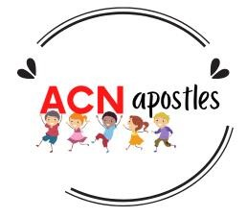
Aid to the Church in Need
The Mustard Seed

For school: four lessons (plus prayer time) or a one day retreat/faith & action day. For parish or youth group activity: adapt as required. Suitable for a one-day retreat (as above) or for arranging as half hour sessions.

Aims:
- To explain the Parable of the Mustard Seed in the context of the Mustard Seed Centre in Syria.
- To learn about the work of ACN.
- To link with Aid to the Church in Need to help the children at the Mustard Seed project and other similar projects across the world.
- To enable pupils to understand that their prayers and fundraising will make a real difference for children in other parts of the world.
- To encourage pupils to see that they can be like ‘mustard seeds’ and give them the opportunity to respond using ACN’s PIA model (prayer, information and action).

A01: Learning About (pupils will be able to): | A02: Learning From (Pupils will be able to):
All:  Retell the Parable of the Mustard Seed.  Explain what the Mustard Seed Centre in Syria is.  Explain what Aid to the Church in Need is.  Respond through prayer and fundraising. | All:  Decide how they can help a child another part of the world through sacrifice, fund-raising, awareness and prayer.
Most:  Say what Parable of the Mustard Seed means. Say why Sr Samia and the Sisters of the Sacred Heart in Syria are helping children.  Link Jesus’ teaching in the Parable of The Mustard Seed to the work of the centre in Syria, ACN and themselves. | Most:  Understand how their efforts can produce fruit when they give them to God.  Be inspired by Fr Werenfried and Sr Samia to build up the Kingdom of God.
Some:  Articulate how the Kingdom of God is the Mustard Seed and how all Christians are called to have faith and participate in God’s plan. | Some:  Articulate a shift in their perception of their own role in the Kingdom of God.

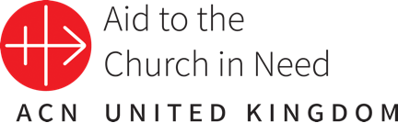

Catholic Self-Evaluation Document - Evidence
Through using the materials provided in “The Mustard Seed”, school leaders will be able to provide evidence to support judgements in the following aspects of the Catholic Self-Evaluation Document (CSED):
Catholic Life and Mission (CLM)
CLM1.3 Moral development
CLM1.4 Catholic Social Teaching
CLM1.5 Respect for self and others.
CLM 2.2 Staff commitment

Religious Education (RE)
RE1.3 Religious literacy
RE2.6 Spiritual & moral development
RE2.7 Variety & resources
RE3.7 Enrichment

Collective Worship (CW)
CW1.4 Influence of curriculum and school life
Religious Education Directory (RED) Links
Knowledge Lenses
The RED identifies six knowledge lenses which detail what should be known by the end of each age-phase.
The six knowledge lenses are Hear, Believe, Celebrate, Live, Dialogue & Encounter.
The ‘Mustard Seed’ resources focus on aspects of the ‘Hear’ and ‘Live’ lenses.

Expectation Ages 5-7
Hear
U1.3.2 Retell, in any form, some of the stories they have heard, recognising these are religious accounts.
U2.3.2 Begin to recognise ‘parables’ as a literary form in scripture with reference to how Jesus uses them to teach people about God.

Expectations Ages 7-9
Hear
U3.3.2 Show a simple understanding of what the Kingdom of God is and is not.
U3.3.4 Show knowledge of the parables of Jesus, making links between them, to show some understanding of what the Kingdom of God is like.
U3.3.5 Retell one of Jesus’ parables making simple links between the chosen parable and Jesus’ message about the Kingdom of God.

Live
U4.3.6 Describe the work of a person or organisation who has been inspired by Jesus to work with those marginalised by societal attitudes to illness, making links with the virtues of faith, hope and love.
U4.4.6 Make simple connections between belonging to the Church and living out the ‘Works of Mercy’ in support of those in need.
U4.5.6 Describe some of the ways in which the Church today (locally or globally) continues the work of Jesus.

Expectations Ages 9-11
Hear
U6.5.1 Show understanding of the scripture passages studied, identifying literary forms and authorial intention.
U6.6.1 Show understanding of the literary forms found in the texts studied, including the use of the metaphor, symbolic language & poetry.

Live
U6.6.1 Explain in an age-appropriate way the meaning of ‘the common good’ and the principles of Catholic Social Teaching.
U6.2.6 Show understanding of the life of individual women today who are responding to God’s call in their life, making relevant links to Mary’s ‘Yes’ to God.

Ways of Knowing
The RED identifies three ‘ways of knowing’ in its Programme of Study that enable skills to be developed at an appropriate level. The development of these aspects allows each knowledge lense to be explored appropriately. The ways of knowing are Understand (lead by the head), Discern (led by the heart) and Respond (led by hands).
‘The Mustard Seed” series of lessons is rooted firmly in each of these strands and provides great opportunities to develop each of these ways of knowing in an age-appropriate manner.
Catholic Social Teaching
The materials will complement the school’s work on developing and sustaining a deeper understanding and implementation of the principles of Catholic Social Teaching (see Caritas Westminster - https://www.caritaswestminster.org.uk/catholic-social-teaching.php), particularly:
- Human Dignity
- Community and Participation
- Option for the poor
- Solidarity and Peace.

Lesson/Session One (EXPLORE) REVELATION (Dei Verbum) God speaks – finding meaning in life
For more information on animals which http://mentalfloss.com/article/55739/11-animals-are-super-smallbirth
SESSION/LESSON 1:
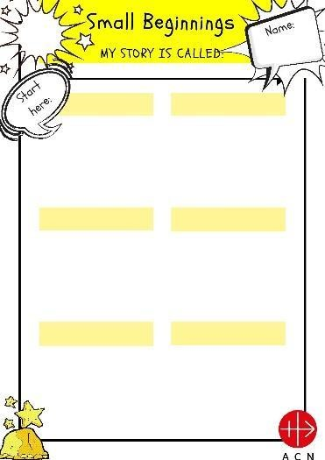
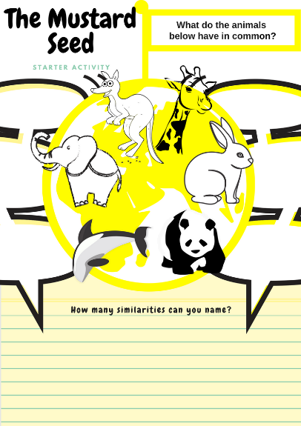
SMALL BEGINNINGS

This session introduces the idea that things can begin very small and become huge.

YOU WILL NEED:
- Lesson 1 Presentation
- Worksheet 1 (Animals: The Mustard Seed)
- Worksheet 2 (Small Beginnings)

Worksheet 1 Worksheet 2 (Small Beginnings) (Animals: The Mustard Seed)

A01: Learning About (pupils will be able to): | A02: Learning From (Pupils will be able to):
All:  Give examples of things which start tiny and become large. | All:  Articulate what significant thing in their own lives had a small beginning.
Most:  Retell the story of how ACN began. | Most:  Understand that no matter how small our efforts seem, they can have a big difference in the world and to other people.
Some:  Explain why, “Someone must begin. Let it be us!” is relevant to the theme of the lesson. | Some:  Articulate why doing what you can in a situation is important.

STARTER
The starter focuses on animals that grow to be very large comparative to their size at birth. It is unlikely that pupils will know this, but this should be a fun activity where they can compete to find as many similarities between the animals as possible. For more detailed information on the relative sizes of the animals, see: http://mentalfloss.com/article/55739/11-animals-are-super-small-birth

- PLAY ANIMATION (slide 2)
Instructions for teachers: Play the presentation and start by asking the pupils to name as many differences as they can between the animals.

- WORKSHEET 1 - Starter Task: Spot the difference & find the similarities (slide 3)
Ask them to write the differences in the speech bubbles around the animals on their worksheet. Next, ask them to name as many similarities as possible – they can add these to their sheets in a different colour. At the end, tell them that there is one important thing they have in common which will be the theme of the lesson. This similarity is that they have tiny babies comparative to their fully-grown adult size.

LEARNING
Explain that for the next few lessons they are going to be learning about things that seem so tiny no one notices them, but that these things can grow to be huge. Explain that these lessons are from the Catholic charity Aid to the Church in Need (ACN) and at the end of these lessons they will be asked to help with its work.

LEARNING 1: EXPLAIN & DISCUSS (slide 4)
What in their lives started small and became big: why is that important – what did it teach you? (e.g., reading - you began by recognising one letter and now you can read a whole book, something you have planted from seed, or a virus).
Ask the pupils to think of things around them that begin very small (e.g., acorns, babies etc.)

LEARNING 2: MAKING LINKS ACTIVITY & SHARING (slide 5)
MY STORY: STORYBOARD WORKSHEET 2 & SHARING OF STORIES (slide 5)

CONSOLIDATION:
Story/Animation: The start of ACN - how it started from one letter (small beginnings) and became the International Charity ACN. (slide 6)

EXTENSION:
“Someone must begin. Let it be us.” How can I use this motto in my life? Could it be a class motto for our charitable work? What would the world be like if everyone had this motto? Where do I see the need? Could I help by just ‘beginning’? In what way is the Church like this?
You could discuss the Church - how it began from one person and over 2000 years later, Christianity is still the largest World Faith. You could explain how the catholic Church is the world’s largest non-governmental provider of education and medical services in the world: 140,000 schools, 10,000 orphanages, 5,000 hospitals and some 16,000 other health clinics.
For more information see https://catholicherald.co.uk/a-worldwide-force-for-good/

PLENARY
Exit cards: draw one of the animals and say why we used them as an example to make the point about today’s lesson.
Ask each child to say one word to explain how ACN began.

COLOURING SHEET
Included: an additional colouring sheet* which could be used during any of the lessons.
The images could be used as additional starters and plenaries, as ‘Mustard Seed Bingo’, cut up by the teacher/leader and given out to play games, e.g.
- tell me one thing about your image
- find a partner, work out how your two images relate, stand in image order of your learning so far, etc…
- one adjective, noun, verb per image (related to lesson)
*Please print on A3 for younger children as some of the images are very detailed.
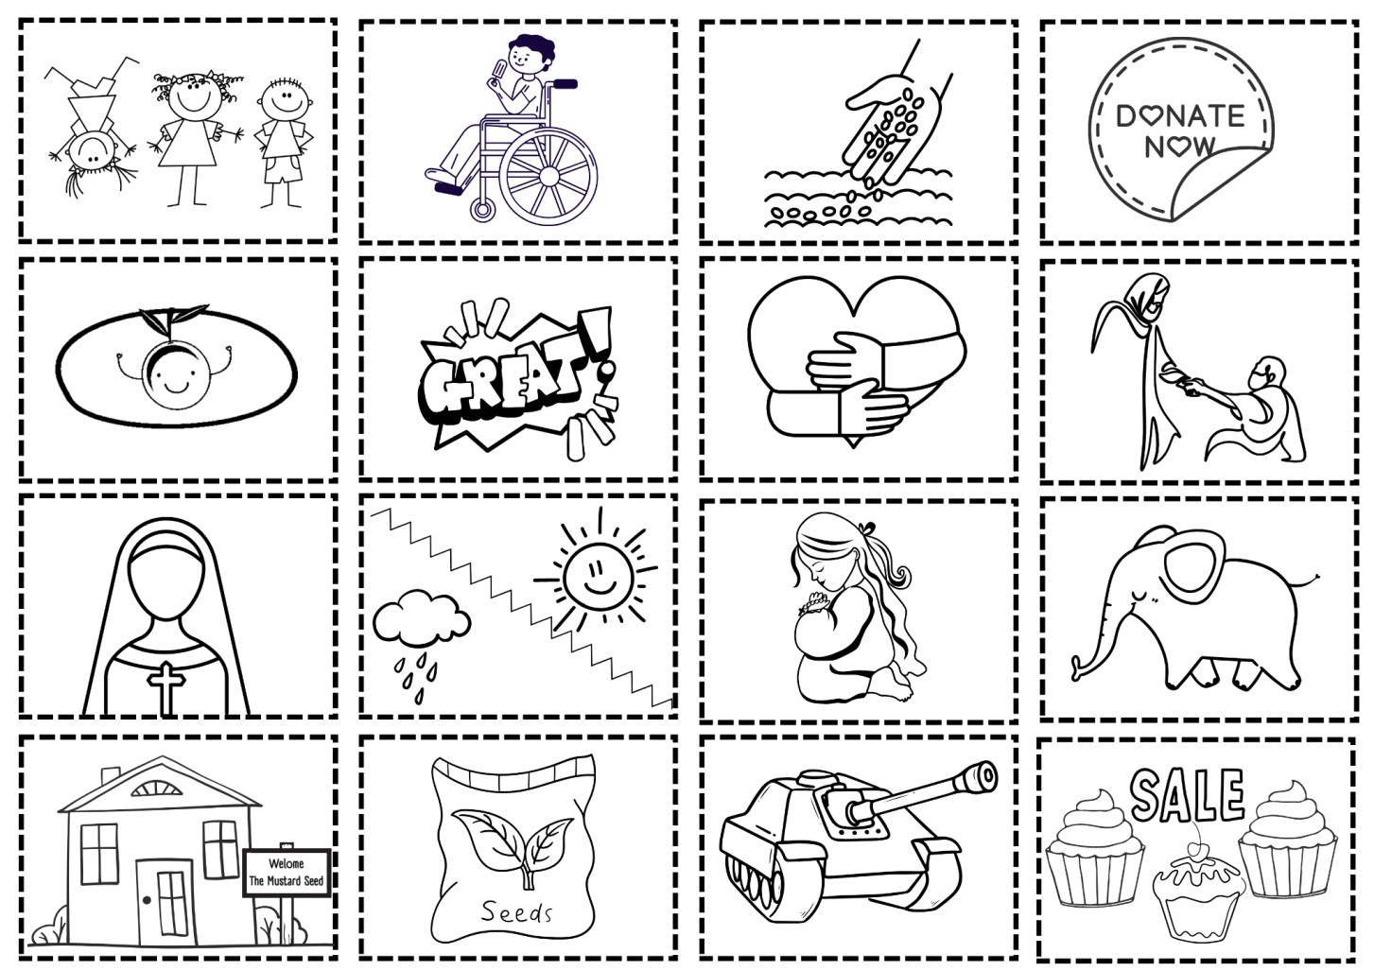

SESSION/LESSON 2: THE MUSTARD SEED
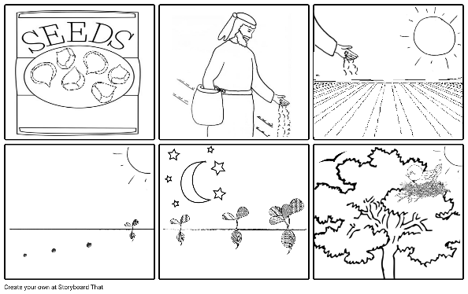
This lesson is about understanding The Parable of the Mustard Seed

YOU WILL NEED:
- Lesson 2 Presentation
- Some mustard seeds from the spices section of a supermarket
- Worksheet 3 (The Parable)

A01: Learning About (pupils will be able to): | A02: Learning From (Pupils will be able to):
All:  Retell the Parable of the Mustard Seed. | All:  Make the link between ‘what we do’ and ‘what God does’.
Most:  Explain what each part of the Parable of the Mustard Seed means. | Most:  Understand that when we do good, God takes our efforts, blesses them and makes them fruitful.
Some:  Link Jesus’ teaching in the Parable of The Mustard Seed to the work of ACN. | Some:  Apply the teaching of the Parable to the Church. Articulate other examples of ‘what we do’ and ‘what God does’.

STARTER: ACTIVITY (slides 2&3)
Pass a Mustard Seed around the class (for allergies, you may want to put the seed into a large frame and have the children pass the frame).

Ask the following questions:
- What do you think this is?
- What is it for?
- Would you find it easily if you dropped it?
- Could something this small be significant for us, birds or nature in any way?

LEARNING 1: THE PARABLE
Play the video clip animation and discuss the parable (slide 4)

Hand out the storyboard (slides 5-12)
You may want to cut this up for the pupils to put it in order and/or put them face down so pupils can turn them over and explain each part of the story in turn.
Other options: colour in the storyboard, write a sentence explaining each image or to draw their own version.

LEARNING 2: UNDERSTANDING THE PARABLE
Discuss what the parable is about (slides 13-19).
The parable is explained in terms of “What we do” and “What God does”.
They may want to draw these images in their books write notes under the title: The Meaning of the Parable of the Mustard Seed.

CONSOLIDATION
Ladder image and discussion questions (slides 20-21).

PLENARY (Slide 22):
Give the mustard seed to a pupil chosen randomly. Ask them one of the questions on the slide and below. Ask the pupil to give the seed to another pupil until all the questions have been answered.

What do the seeds represent?
What does God provide?
How is the parable like ACN?
What does the parable teach us about trust in God, patience, faith, God’s power, our role in building God’s kingdom?

OR for a parish or youth group setting: use the storyboard as a focus for prayer and reflection.

SESSION/LESSON 3: THE MUSTARD SEED CENTRE AND ACN

This lesson is about understanding the work of Sr Samia and the Sisters of the Sacred Heart at the Mustard
Seed Centre in Syria

YOU WILL NEED:
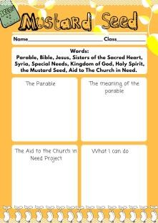
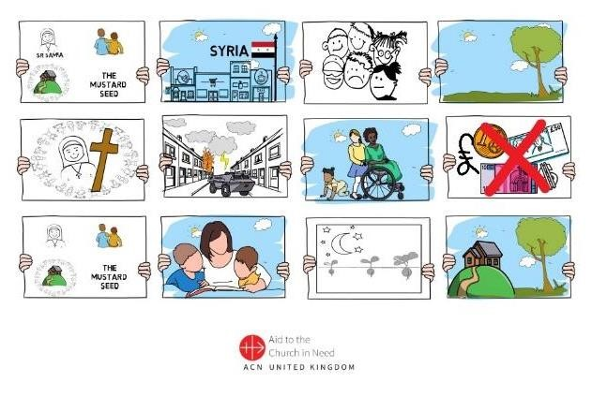
- Lesson 3 Presentation
- Worksheet 4 (Mustard Seed)
- Worksheet 5 (Sr Samia and the
Centre)
- Sr Samia and the Mustard Seed Notes

A01: Learning About (pupils will be able to): | A02: Learning From (Pupils will be able to):
All:  State some facts about the beginning of the Mustard Seed Centre. Explain who is helped by ACN and the Mustard Seed. | All:  See how their efforts are used by God.
Most:  Explain how the Sr Samia’s work and Aid to the Church in Need are examples of message found in the Parable of the Mustard Seed. | Most:  Understand that when we do good, God takes our efforts, blesses them and makes them fruitful. Discern how they can apply this message practically.
Some:  Ask meaningful questions about how this applies to them. | Some:  Be moved to reflect on how God is calling them.

STARTER: ACTIVITY Slide 2-3
Ask pupils to discuss in pairs what they can remember about the last two lessons.
Each pair joins with another pair to become groups of four.
Together, fill in the first two sections of Worksheet 5. Set aside to finish later.

Slide 4
Look at the storyboard and guess what it is about:
Where is it?
Who are the main characters?
What do you think is going on?
What images are surprising?
What would you like to ask the artist?
How do you think this relates to the Parable of the Mustard Seed?

LEARNING 1: THE CENTRE IN SYRIA (slide 5)
Play the animation, read the story and discuss using the questions below:

Discussion Questions (slide 6)
- Why did the Sisters want to help the children?
- What did the Sisters do?
- What difficulties did they have?
- What happened in Syria in 2011?
- Why did they have to trust God?
- How did the Mustard Seed Centre get its name?
- Can you see any similarities with the parable?
- How did Aid to the Church in Need help the Sisters?
- What did the Sisters do to make The Mustard Seed a reality? What did God do?
- How did it change the lives of the children and their families?
Worksheet 5 (Sr Samia and the Centre)

LEARNING 2: STORY (Introduce: slide7)
Read the following true account of Mahere Mansor and show the pictures (slides 8-12)

Mahere Mansor is a young adult of 18 years; he is mentally disabled. His father died as a Christian*martyr during the war. Mahere was with his father when he died, he saw everything and seeing what happened made him very sad and depressed. When he went to the Mustard Seed Centre and only ever spoke of his Dad.
Sr Samia and the staff have given him specific educational and social help and have even supported his family.
Today, Mahere has made a lot of progress and works in the workshop with the adults. His mother even takes part in the Mothers’ Club which is helping her to recover from the sadness of her husband being killed.
All this, thanks to the perseverance of people who support him and his presence at The Mustard Seed Club, which for him, is his lifeblood.

*this means that he died because he either wouldn’t give up his belief in Jesus or in because he was a Christian

Slides 13-25
Explain that these are real pictures from the Mustard Seed Centre.
John Pontifex who works for Aid to the Church in Need in the UK took these photos when he visited the centre. The video on slide 16 is of Sr Samia and the children at the Mustard Seed Centre.

Slide 26:
The war in Syria began on 15th march 2011
This video was made for ACN’s Christmas Campaign in 2019, but similar campaigns run every year.
This year’s Advent Resource will be focusing on children’s projects in Syria.

CONSOLIDATION ACTIVITY (slide 27)
Fill in the third box (“The Aid to the Church in Need Project”) of the worksheet outlining how the Mustard Seed Centre began.
Using the images on Worksheet 6 (either) draw a storyboard explaining The Mustard Seed Project Write a poem or prayer about the centre.

PLENARY:
Show the video clip on (slide 28) which is another example of how ACN have helped the children in Syria. Sr Samia and the Mustard Seed Notes (Sr Samia writes):
Please make clear that although this project started many years ago it is still supported by ACN. This is one example of one project… you could ask the children to guess how many projects ACN helps every year. The answer is around 5,000.
In 2006 in the old town of Homs we opened "The Mustard Seed" which is a day-care centre for mentally disabled children, suffering from Down syndrome, autism or other illnesses.

At first, we started with three children. Each beginning brings challenges and hope at the same time: for this reason, I named the centre The Mustard Seed which starts small but will become a great tree according to the gospel. When we started in 2006, we had no money and I was not paid for my work. The image that was before me was that there are children with disabilities who need this service and it is necessary to continue. I had faith like the ‘sower of the seeds’ and knew that God would make the small grains grow.

By 2009 the centre had grown through faith and hope. We were able to look after 30 children in classes every day. I felt joy in this growth like the birds that sing and live in the Mustard Tree.

In 2011 the war in Syria caused many difficulties and great sadness.

It wasn’t safe to stay in Homs so we had to leave the neighbourhood with the children. It became impossible to continue our activities. The centre closed after it was destroyed by bombs in March 2012.

In May 2012, with the support of associations and ACN, the centre reopened its doors in an area less affected by the violence. We had continuous hope despite all the difficulties. Many moments were very unpleasant, especially having to work among the bombings, but we needed a safe place for the children.
In this dangerous period with the bombings and explosions we created four centres in four neighbourhoods in the city which was safer for the children.
At that time, the Centre and the area were barricaded – no one could enter.
In 2014 we were able to go back to the Centre, which was completely destroyed.
In December 2015, the rebuilding of the Centre which was destroyed by the war began. We worked to make the building
fit for purpose for children’s activities. Today the Mustard Seed Centre is always open. This year we welcome 90 children and young adults and offer them a programme adapted to all academic and social levels and which improve their independence and develop their talents.
Our Centre has defied violence and destruction and continues its mission despite the difficult years and all the setbacks. We continue to work with people with disabilities to support them and offer them a safe haven in the middle of fearful times. This helps them grow more confident in their abilities. Through our work aim to develop their abilities at all levels to help them be assimilate within the community and to respond to their needs
Final Word: I always say that The Mustard Seed has grown through faith, as Jesus said in the Bible and all the bird of heaven rest in its branches.
That we are still here, is a sign of hope. Finally, I thank God for all the fruits and that we can offer fruits despite everything that has happened.

LESSON 4: MY RESPONSE

This lesson is about showing pupils that they too can be like mustard seeds. The emphasis is on the things they can actually do to make a difference and prayer. During this time, they should decide what activities and prayer commitments they would like to undertake for ACN projects around the world.

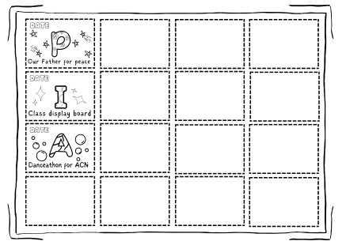
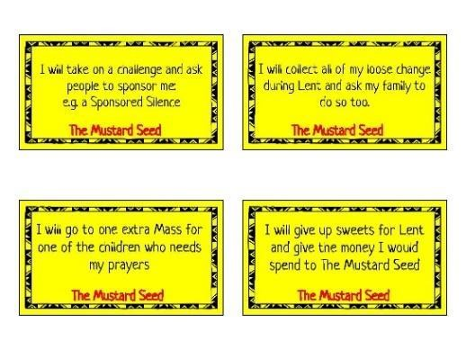
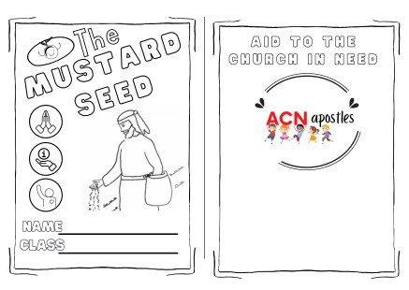
YOU WILL NEED:

- Presentation 4
- Post-it notes
- PIA Card Templates
- The Mustard Seed Response Cards
- Space for group work
- Pens/pencils

A01: Learning About (pupils will be able to): | A02: Learning From (Pupils will be able to):
All:  Will have decided on their own PIA Choices. | All:  Will understand that their contribution matters .
Most:  Articulate why each person, as a follower of Jesus, is called to help others.  Articulate why prayer for others is important. | Most:  Understand that their prayers and acts of charity will be blessed by God, even if they can’t see it (like the Mustard Seed growing and Sr Samia when they had to leave the centre).
Some:  Have made the connection between ACN’s mission and the mission of Jesus. | Some:  Make reference to the idea of vocation in relation to this series of lessons.

STARTER (slide 2)
Reread the Parable of the Mustard Seed or ● ask children to explain it to each other.
  - in groups of 6 tell the parable in using one sentence each ● act out the parable.
  - game: groups instant ‘freeze frame’ scenes from the parable and whilst the rest of the class guess the part and explain the meaning (for points).
  - starter sentences: the part of the Parable of the Mustard Seed I liked most is… etc.

RECAP: ACTIVITY 1 (slide 3)
Summarise learning from the last lesson.

ACTIVITY 1 & FEEDBACK (slides 4-5)
Group activity to develop understanding and encourage discernment.

  - Sr Samia is like the Mustard Seed because…
  - ACN is like the Mustard Seed because…
  - We can all be like the Mustard Seeds by…
  - The Church that Jesus began is like Mustard Seed because…
  - These lessons have made me think about…
  - What I would like to ask Jesus is…
  - I would like to love God more by…
  - I would like to love others more by…

ACTIVITY 2: RESPONSE CARDS & CARD
Explanation (slides 6-7)
PRAYER - INFORMATION - ACTION
Explain that ACN invites people to respond by actively helping those who are suffering. The model ACN uses is called ‘PIA’ (if you have time you could ask the children to guess what PIA stands for or play hangman or another word-guessing game).

Further Information:
Explain that when we pray for others, we are giving them a gift that is actually like the Mustard Seed. When we pray, God takes our efforts and uses them in ways we do not fully understand. The same way the seed grows without our knowing what’s happening, God uses our decision to pray, our doing so (which is the joining of our hearts to God’s Kingdom) and makes it something which is beyond what would have happened. God gives us the privilege of being able to make a difference for someone else (or ourselves) by offering it to him in prayer. Every time we choose to pray, we are doing something selfless. God wants us to be co-creators with him – this means that we build his Kingdom of Love through our lives with him.

Explain that people need to know about those being helped by ACN. Educating ourselves about the work of ACN and spreading the news to others is vitally important.

As Christians we are called to act. ACN helps: the poor, refugees, the sick, the elderly, those who are alone or abandoned, orphans, those who are persecuted for their beliefs, people who suffer because of war, famine, natural disasters and terrorism.

Last year ACN funded close to 6,000 projects funded for suffering Christians.
The largest single recipient of ACN help in 2022 was Ukraine. A total of 353 projects were supported in the country, especially to help priests, religious, seminarians and other Church workers who have been working with refugees and others in desperate situations.

Tell the children that they are invited to join ACN by enabling the charity to continue helping people like Sr Samia and the children at the Mustard Seed project. Show the card on slide 6, explaining that ACN want to encourage them to help through their prayers, information (receiving and giving) and action (fundraising). The children can record their PIA responses on a card.

Invite children to give ideas under the three headings: Prayer, Information and Action.

If they need help/if you have time, then, in groups begin ACTIVITY 2: RESPONSE CARDS

- Give out packs of response cards.
- Place cards in centre of group (4-6 children per group).
- Each player turns over a card, reads what it says and decides if it should go under the heading of prayer, information and action.
- Child places the card under the relevant heading and explains to the rest of the group why s/he thinks so (you can add rules like ‘ask a friend’ if need be).
- At the end each child writes on their post it notes the top 5-10 PIA choices they would like to commit to over the coming weeks (or for Lent, Advent etc) to support and fundraise for ACN.

CONSOLIDATION (slides 9-13)
Explain how they will fill in the cards. You can use the templates, or the children could make their own. These could be brought up to the altar during a liturgy later.

CONCLUSION (slides 14-17)
ACN has many other projects - here are some examples.

PLENARY
Share ideas and plans

Lesson YouTube Clips

LESSON 1

SLIDE 2 - Animal Starter
https://youtu.be/DcqOxdTADKA

SLIDE 6 - ACN Story
http://www.youtube.com/watch?v=nEGhJ81gm3Q

LESSON 2

SLIDE 4 - Recap
https://youtu.be/2q8o6NJNXH0

LESSON 3

SLIDE 5 - Mustard Seed & Sr Samia Story
https://youtu.be/PCPMmdMzUBs

SLIDE 16 - Sr Samia https://youtu.be/6BZE6fLrjgE

