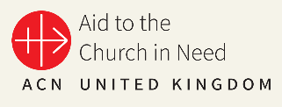
Aid to the Church in Need
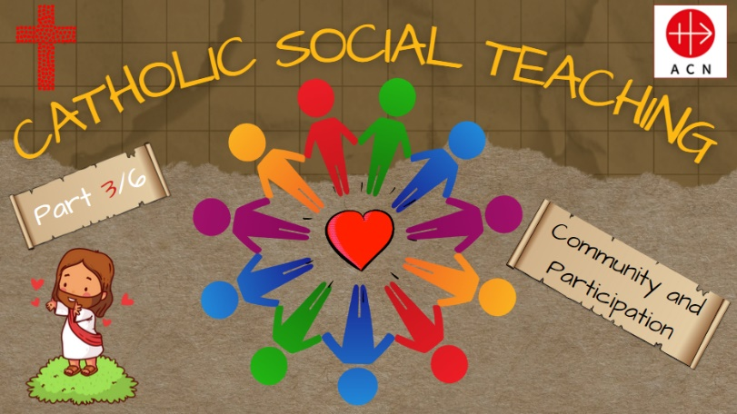
‘Community and Participation’ Support Document
‘Let each of you look not only to his own interests, but also to the interests of others.’
Philippians 2: 4

This resource is the third in a series of six presentations (to be released on a half-termly basis) which has been created to support schools in developing pupils’ knowledge and understanding of Catholic Social Teaching (CST) as outlined in the revised RED, ‘To Know You More Clearly’. This presentation introduces/revises the various precepts of CST and subsequently focuses on the ‘Community and Participation’. The presentation has been designed/structured so that the various components can be delivered as a whole, or different elements can be incorporated into different lessons/assemblies with a CST focus, particularly in the relation to the ‘Community and Participation’. The remaining presentations in the series will be as follows:
Summer 1: The Dignity of Workers
Summer 2: Human Dignity
Autumn 1: Care of Creation
Previous presentations (available in the Primary Resources section of the ACN UK website – see link below) are as follows:
Autumn 2: Preferential Option for the Poor
Spring 1: Solidarity and Peace
A brief introduction to the history CST (including an excellent ‘CST in Three Minutes’ video from Trócaire (https://www.trocaire.org/ ) is included in the first presentation (Preferential Option for the Poor: sides 8 – 30); this can be found in the Primary Resources section of the ACN website using the following link: https://acnuk.org/resource/primary-acn-catholic-social-teaching/
If your children have no prior knowledge of the origins of Catholic Social Teaching and its various precepts, this video provides an excellent introduction.
We hope that you and your pupils find this resource both engaging and informative as we celebrate the Church’s ‘best kept secret’!
- Aims
Through using these materials, pupils will:
- Explore the various precepts of Catholic Social Teaching (CST) in action through the work of ACN (Focus: Community and Participation).
- Understand how CST is embedded in scripture and explore how this is evident in both the Old and New Testaments.
- Reflect on how the world would be a better place if everyone chose to love their neighbour as themselves.
- Develop an understanding of the work of ACN to support poor and vulnerable Christian communities around the world (Focus: Pakistan).
- Reflect on societal exclusion and consider how they could follow in the footsteps of Jesus through supporting the work of ACN.
- Be able to describe how the work of ACN in the service of others is an example of following ‘The greatest commandment’.
- Engage with fundraising and prayer to support the work of ACN.
- Catholic Self-Evaluation Document - Evidence
Through using this resource, school leaders will be able to provide evidence to support judgements in the following aspects of the Catholic Self-Evaluation Document (CSED):
Catholic Life and Mission (CLM)

CLM 1.3 Moral Development
CLM 1.4 Catholic Social Teaching
CLM 1.5 Respect for Self and Others
CLM 3.5 Commitment to Catholic Social Teaching
CLM 3.7 The Catholic Curriculum

Religious Education (RE)

RE1.1 Development of Knowledge, Understanding and Skills
RE 1.3 Religious Literacy
RE 2.6 Spiritual and Moral Development
RE 3.1 RED
RE 3.5 Curriculum Design
RE 3.7 Enrichment

Collective Worship (CW)

CW1.4 Influence of Curriculum and School Life
CW 1.5 Impact
CW 2.1 Centrality
CW 2.4 Use of scripture
CW3.5 Leaders’ Knowledge and Skill

- ‘To Know You More Clearly’: The Religious Education Directory (RED)
The spiral structure of the curriculum enables a build-up, layering a critical dimension each year, deepening pupils’ understanding of the story of salvation, developing a common language, and exploring the ‘memory of the Church’ and her teachings and how these have formed part of the history of ideas in the development of humanity.
The spiral pathway students follow from their first steps into Catholic education means that teachers can plan for progression, moving through basic questioning and notional understandings to ever deeper levels of engagement with Christianity’s divine and human drama and its significance for humankind. (RED: ‘To Know You More Clearly’; 2023)
Whilst these materials do not aim to cover the full progression and understanding required by the RED in its spiral curriculum, they do aim to supplement and enhance this learning.
Knowledge Lenses – End of Phase Expected Outcomes
The RED identifies six knowledge lenses which detail what should be known by the end of each age-phase. This resource can support teachers in helping to evidence expected outcomes in the Hear, Believe, Celebrate and Live knowledge lenses.
Go to pp33 – 34 of ‘To Know You More Clearly’ for further commentary on Catholic Social Teaching within the revised RED.
Ways of Knowing
The RED identifies three ‘ways of knowing’ in its Programme of Study that enable skills to be developed at an appropriate level. The development of these aspects allows each knowledge lens to be explored appropriately. The ways of knowing are Understand (U), Discern (D) and Respond (R).
End of phase Age-Related Expectations, that could be linked to this resource are listed below.
- Age 5 - 7
R1.3.2. Reflecting on how Jesus is a ‘light’ for all people and consider how they can bring ‘light’ to their families and communities.
U1.6.2. Recognise that Catholics are a part of a global Christian family, and all Christians are sisters and brothers.
R1.6.1. Consider how Christians in their local parish community could work together to help people.
R1.4.2. Considering what they might give up and choose to do to help others.
U2.6.2. Describe an initiative Christians work on together locally and/or globally in the service of others.
R2.1.2. Reflecting on how actions can help or harm themselves and others and what this could mean for their friendship with God.
D2.6.1. Consider an answer, with relevant reasons, to the question ‘Who is my neighbour?’
- Age 7 - 9
R.4.1.1. Considering how their own lives and the lives of their communities could be transformed by the virtues of faith, hope and love.
R.4.3.1. Reflecting on those that society excludes today and consider how they could show love for these people as Jesus did.
R.4.3.2. Considering how Jesus serves others and discuss how Christians can follow this example today. What could this mean for their lives and the lives of their local communities?
R.4.4.1. Reflecting on how the life and work of a person or organisation (historical or contemporary) lives out the works of mercy and/or the love for those oppressed by poverty and the inspiration they offer for their life.
R.4.4.2. Reflecting on what it is they need to change about themselves during Lent to be better people and discuss how focusing on one of the acts of mercy could help with this, for example, caring for the most vulnerable in their communities.
R.4.5.3. Reflecting on how Christian communities continue the work of Jesus in the community where they live.
- Age 9 - 11
R5.1.3. Discussing what loving our neighbour means for Christians today, for example, welcoming asylum seekers and refugees. Express a point of view and give reasons relating to the Church’s teaching on the common good and love of neighbour.
R5.3.4. Reflecting on how the communities they are part of could be transformed if everyone chose to love their neighbour as themselves.
R5.5.2 Reflecting on how they can use their gifts to make a better world.
R6.1.1. Considering they ways in which their life and the life of their communities could be transformed by taking seriously the belief in the innate dignity and equality of all human beings.
R6.4.2. Considering how love of neighbour could transform their life and the lives of the communities they are part of, describing the actions they could take to begin this transformation.
R6.5.3. Reflecting on how the work of charities can support people facing injustice or persecution.
U6.5.6. Describe how one charity studied witnesses its Christian faith through its work.
U6.6.1. Explain in an age-appropriate way the meaning of ‘the common good’ and the principles of Catholic Social Teaching.
U6.6.2. Describe some ways Christians work together with people of different worldviews to promote the common good.
- Presentation Overview/Notes
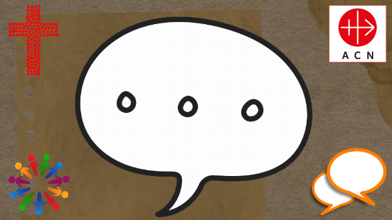
This slide appears throughout the presentation and is intended to provide an opportunity for pupils to discuss their ideas/thinking related to the content. If required, you could duplicate this slide for use elsewhere in the presentation as appropriate.
Slide 1 | If you have completed the first two presentations in the series (Preferential Option for the Poor; Solidarity and Peace), explain that this is the third of a set of six (3/6) and that the focus for this ‘session’ is ‘Community and Participation. If you have not used the first presentation, you could use slides 8 – 30 from this presentation to introduce the concept of Catholic Social Teaching (CST) to the children using this link. (https://acnuk.org/resource/primary-acn-catholic-social-teaching/)
Slide 2 | ‘Let each of you look not only to his own interests, but also to the interests of others.’ (Philippians 2: 4)  Q: How might this quote from Philippians relate to today’s theme?  Q: What word could be used in place of interests?  Q: Could this be something that we focus on during Lent?
Slide 3 | ‘Each of you should use whatever gift you have received to serve others, as faithful stewards of God's grace in its various forms.’ (1 Peter 4 – 10)  Q: What is this piece of scripture telling us to do?  Q: What ‘gift/talent’ do you want to use more often during Lent to serve others?
Slides 4 - 11 | A brief introduction/reminder of the various precepts (themes) of Catholic Social Teaching (CST) that will be explored in this series of presentations; today’s focus is ‘Community and Participation’.
Slides 12 - 14 | Introduction to today’s CST theme – ‘Community and Participation’.
Slides 15 - 23 | After a brief discussion about what a ‘community’ is in general terms (see Glossary of Terms) ask the children to think of five different ‘communities’ that they belong to; depending on the age of the children, you might want to provide them with some initial ideas, including family, school and parish/church community.  Q: What do the communities that you have thought of have in common with each other?  Q: What is ‘different’ about some of these communities?  Allow children time to discuss this in pairs/groups; share ideas (slide 23).  Q: What do you think is important about being a ‘member’ of these communities? (highlight the importance of using their gifts/talents).
Slides 24 - 26 | As Christians, we are called to be members of a ‘caring community’?  Q: What do you think this means?  You could make reference to your school Mission Statement, class charters etc.  Allow pupils time to discuss their ideas/thinking (talk partners/groups/class).  Share the definition of a ‘caring community’ on slide 26; this could be simplified for younger children as required.  Q: What does a ‘respected place’ mean?  Q: What does ‘diversity’ mean to you?
Slide 27 - 31 | Introduce the concept of ‘participation’ and explain that this is an integral part of being part of a community.  Slide 28 outlines the importance of being an ‘active’ member of our community as we ‘look out’ for others in our community; this is extended to our ‘global community’ on slide 29. Depending on the age of the children, this may require further explanation/exploration; this will be revisited when we focus on the work of ACN in Pakistan.
Slides 32 - 37 | Explain to the children that Pope Francis is continually challenging us to follow in the footsteps of Jesus through living our lives in the way that God wants us to, particularly in relation to the common good and respecting each individual’s dignity and worth.  Slide 33: ‘We cannot keep ourselves shut up in parishes, in our communities, when so many people are waiting for the Gospel!’  Q: What is Pope Francis ‘challenging’ us to do?  Slide 34: Q: What do you think that Pope Francis means when he says that ‘so many people are waiting for the Gospel’?  Slides 35 – 37: Allow children time to discuss their ideas/thinking; do they have any practical examples of what they do as part of their school community to ‘spread the Gospel’ through supporting those in need at a local, national or global level? Share pupils’ thoughts/ideas as appropriate.  Q: During Lent, how could we ‘spread the Gospel’ in our school community?  Q: What could we do in the local/global community?
Slides 38 - 41 | Slide 39: ‘Beloved, if God so loved us, we also ought to love one another.’  (1 John 4: 1 1)  Q: How does the quote from John’s Gospel link to Pope Francis’ quote?  Q: How does this link to what Jesus told us about how we should treat our ‘neighbour’?  Q: How can we show others that we love them, even if we never actually meet them?  Provide opportunity for discussion as appropriate.
Slides 42 - 47 | Share ‘The Parable of the Great Banquet’ (Luke 14: 12 – 24) with the children; reinforce the fact that all aspects of CST are embedded in scripture; CST helps us to understand how to ‘bring the Word to life’ in our daily lives. https://www.biblegateway.com/passage/?search=Luke%2014%3A12-24&version=NIV  (Depending on the age of the children, you may wish to use an adapted version of this parable)  Q: What is Jesus trying to teach us through this parable?  Slide 45: Further explore verse 13 – 14:  Q: What does this tell us about when we try to support other people in the various communities that we belong to?
Slides 48 - 49 | If you have not used the previous CST presentations, introduce the children to ‘Aid to the Church in Need’ (ACN); explain that ACN works on over 5000 projects in over 140 countries all around the world, helping to support the Church in its mission, and bringing hope and solidarity to millions of people.  From priests to catechists and seminarians to Sisters, the donations received enable ACN to help persecuted and suffering Christians live out their faith.  Refer to the quote from Pope Francis shared earlier.  Q: Can you see how ACN are helping these communities that are ‘waiting for the Gospel’ through their work?
Slides 50 - 56 | These slides focus on some of the work/projects undertaken by ACN to support/build new Christian communities in various regions of Pakistan; explain that many of the people in these communities have been persecuted for their beliefs and have often had to re-locate to a safer area/place so that they can continue to practice their faith.  Share the examples of how ACN has supported these communities using the images/commentary on slides 52 – 55.  Slide 56: Allow children the time to reflect on the work of ACN in Pakistan; explain that these slides demonstrate a tiny fraction of the work undertaken by ACN and that all of the projects outlined are only made possible by charitable donations.  Q: How does this link to the various pieces of scripture that you have heard during this presentation?
Slides 57 - 58 | Slide 57: Explain that ACN is a charitable organisation and that as such, they are dependent on contributions from individuals/organisations; through supporting the work of ACN, people are demonstrating their support/love for the communities included in the previous slides, and many more besides all around the world. Could your class/school support the work of ACN through organising a fundraising event (see slide 66)?  Slide 58: Reinforce the importance of remembering the people/communities that ACN supports in their prayers.
Slides 59 - 63 | You Could Also…  These slides provide some possible ideas that you could use to help children further embed their understanding through practical application. These are merely ideas and can be edited/deleted as appropriate.  Activity 1: Write a letter to your local MP asking them to organise a local community project for the most vulnerable people in your area.  Activity 2: Write a prayer/prepare a prayer service to support the work of ACN and one of the communities that it supports.  Activity 3: Design a poster for your parish to promote the work of ACN.  Activity 4: Organise a class/school fundraiser to support the work of ACN.
Slides 64 - 66 | These slides serve as a possible ‘plenary’ session which provides the children with the opportunity to reflect on their learning/understanding at an appropriate level.  Q: What have you learnt from this session?  Q: How will you be a more ‘active’ member of the communities that you belong to?  Q: Do you have any questions/further thoughts?
Slides 67 - 73 | Prayer and Reflection: children could be asked to read various prayers depending on their age; provide an opportunity for spontaneous prayer as appropriate. Previous scripture passages/quotes could also be incorporated into this collective worship session, along with an appropriate song; The Mark 10 Mission website contains a library of possible worship songs/hymns, including lyrics: https://www.themark10mission.co.uk/worship-songs  Remind children that their ongoing prayers for the people/communities supported by ACN are greatly appreciated/welcomed.
Slides 74 - 75 | The CST theme for Spring 2 is ‘Community and Participation’; this will be made available to schools before the February half-term.
Slide 76 | Glossary of Terms – definitions of key terms/vocabulary used during the session; this is not an exhaustive list and you may need to explore other vocabulary at an age-appropriate level. See also the ‘Glossary of Terms’ from the first two sessions.
Slide 77 | Closing Slide.

- Fundraising for ACN
ACN is always grateful for the funds raised for its projects. Please note that the projects mentioned in this presentation are an example of its work. Your funding may go to these or similar projects.
Thank you for all that you do to support the work of ACN, both in your fundraising and in your prayers which are equally important.
Please let us know how you have raised funds via
- Twitter (X): @acn_uk
- Instagram: @aidtothechurchinneed_uk
(ACN – January 2024)

