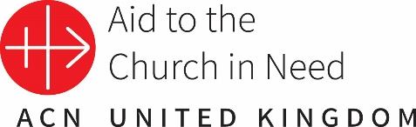
Maisy Milk Rosary for Peace
Instructions for teachers/leaders.

These prayers and reflections are to be used with the accompanying presentation each day of your Monday-Friday Maisy Milk Rosary.

You may decide to focus on one part of the reflections below or invite the children to take specific lines to lead their classes in prayer.

Each intention is linked to an ACN project. Children could decide to raise money for one or all the projects below.

Maisy Milk Rosary for Peace – Monday: The Annunciation
Praying for the children of Lebanon.

The Annunciation: Luke 1:26-33 - The Angel Gabriel announces the birth of Jesus to Mary.
In the sixth month the angel Gabriel was sent by God to a town in Galilee called Nazareth, to a virgin engaged to a man whose name was Joseph, of the house of David. The virgin’s name was Mary. And he came to her and said, “Greetings, favoured one! The Lord is with you.” But she was much perplexed by his words and pondered what sort of greeting this might be. The angel said to her, “Do not be afraid, Mary, for you have found favour with God. And now, you will conceive in your womb and bear a son, and you will name him Jesus. He will be great and will be called the Son of the Most High, and the Lord God will give to him the throne of his ancestor David. He will reign over the house of Jacob forever, and of his kingdom there will be no end.” (New Revised Standard Version Catholic Edition)

Reflection through the eyes of Mary.
When I got up that morning, of all the things I thought might happen, seeing an angel wasn’t one of them. The message the angel Gabriel announced was that I was to give birth to the Son of God. The Saviour promised to us over centuries was coming to earth and I was to be part of the plan of God. I was overwhelmed, excited, confused but peaceful. I knew this was God’s plan and even though I didn’t understand, I trusted that God knew and that’s all I needed.

Prayer Intention.
Today we are praying for children in Lebanon. In the video, Mother Maguy said, "Being a mother is to have a heart of a mother. In this situation where our country is passing through, I cannot say 'no' to any poor coming to us. We are trying to be Jesus in our place." We ask Our Lady to pray with us as we offer this decade of the rosary for the families living in poverty. Dear Lord, bless and strengthen Mother Maguy and all the sisters who care for those in need.
Mary trusted in God when the Angel Gabriel told her that she would give birth to Jesus. The Mother of God, said yes when she was asked to bring Jesus into the world. Mother Maguy in Lebanon said yes to the poor coming to her for help. May we trust in God too, even when we don’t understand and try to bring Jesus to everyone we meet.

Fundraising with Maisy Milk

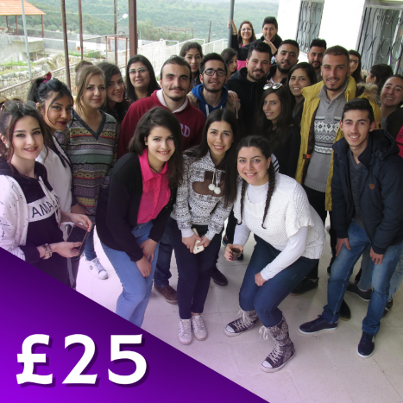

ACN is supporting a project in crisis-torn Lebanon that is giving hope to over 400 children and young people from 35 small, isolated villages. Each week they gather to enjoy creative arts, play games, and gain fellowship together by studying the Bible and connecting with God through nature. This vital project is helping young people to remain in their homeland and strengthen their faith.
Could each class raise £25?

Your kind Gift of Faith helps cover the running costs of church-run youth programmes in the places where we work.

Additional Information for teachers, leaders and catechists: Lebanon
The events in Lebanon over the past four years have had a devastating impact, and today over 70% of the population is living in poverty. Since October 2019, Lebanon has been ravaged by an economic, financial, and socio-political crisis aggravated by the Covid-19 pandemic and the August 4, 2020, explosion in the port of the capital Beirut. The political situation in Lebanon remains at a stalemate, and the country still has no governing cabinet or President.
The Sisters of Notre Dame du Bon Service have been present in the region for 70 years. Since their arrival, they have witnessed to the universal love proclaimed by Jesus, by serving all their brothers and sisters. They work to maintain a Christian presence in the region. One of their means of action, among others, is the gradual establishment of schools, open to all and especially to the region's Christian minority, to whom they offer the opportunity to study free of charge. They want the evangelical spirit to guide their schools. Therefore, they employ a majority of Christian teachers to ensure that this spirit is firmly implanted within the school. Catholic schools are one of the only places in Lebanon where Christian and Muslim children live together peacefully, helping to improve inter-religious relations in the country.

Maisy Milk Rosary for Peace – Tuesday: The Visitation
Praying for the children of Ukraine.

Luke 1:31-45: Mary Visits Elizabeth
At that time Mary got ready and hurried to a town in the hill country of Judea, where she entered Zechariah’s home and greeted Elizabeth. When Elizabeth heard Mary’s greeting, the baby leaped in her womb, and Elizabeth was filled with the Holy Spirit. In a loud voice she exclaimed: “Blessed are you among women, and blessed is the child you will bear! But why am I so favoured, that the mother of my Lord should come to me? As soon as the sound of your greeting reached my ears, the baby in my womb leaped for joy. Blessed is she who has believed that the Lord would fulfil his promises to her!”
(New International Version)

Reflection through the eyes of Mary
Immediately afterwards I knew I had to arise and go to visit my cousin. It was a long journey, but I had to be with her. Amazing things were happening and not just to me! I had the Son of God living in me – the baby who would be born into poverty and yet change the world forever. Elizabeth had become pregnant too. I could see tears of love in her eyes when she saw me. She was different, something had happened. She knew!! She started praising God and felt the baby in her womb leap for joy.

Prayer Intention
Lord, we ask you to bring peace to Ukraine as we offer this decade for the children who are suffering as a result of the war. Jesus, we pray that those who believe that fighting is an answer will have their hearts changed. Help those who have lost relatives, those who have no food or electricity and those who fear for the future. Jesus you came to bring peace. Help us to be like Mary, to be prepared to bring your love to others and may all people receive you as Elizabeth did, with joy and faith in your goodness.

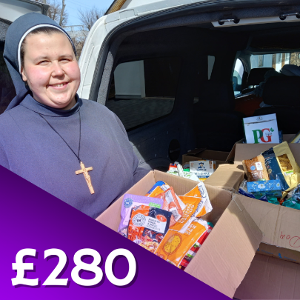
Fundraising with Maisy Milk
In the city of Lviv in western Ukraine, Fr Gregory provides food parcels and gives shelter in his parish to refugee families fleeing the fighting. In the first 100 days of the war around 2,000 refugees received emergency aid as they passed through his parish. He says, “Today we have 100 people here from the destroyed cities in eastern Ukraine – the great majority are women and children”.
Could you raise £280 for families in Ukraine?
Could each year group raise £280?
Your gift could enable more women and girls to transform their lives in parts of the world where they are not valued and treated as second-class citizens.

Additional Information for teachers, leaders and catechists: Lebanon
Natalya is the mother of a three-year-old girl. Her husband has been at the front for 18 months. She is one of the people receiving support and companionship from the House of Mercy, founded by the Archdiocese of Lviv. “Here, I don’t feel lonely, and I can talk about my fears. Being the wife of a soldier on the front line means a lot of suffering. The only thing you want is for your husband to survive. But right now, it seems to me that everyone is carrying a burden – all of my friends, my family; I don’t want to cause them any additional sorrow. Coming here gives me stability, for my own good and for my husband. It’s helping me to guard against madness and I feel stronger as a result. It has enabled me to return to a normal life; I had been wandering around like a lost spirit.

The Sisters of Nazareth. They look after families with young children who had to evacuate their homes. Their first shower, and the opportunity to change into fresh clothes after reaching the sisters, will forever remain in their memories. In response to the closure of schools, we improvised

education for the children ourselves. And we set up prayer groups – anything we could do to develop a trace of normality and comfort. People often said to us: ‘Sisters, are you’re staying? If you are, we’re staying too.’ Since then, Sister Bohumila has re-opened the kindergarten, even though far fewer children are now attending. Returning to everyday life is very important for them. ACN is has supported the Sisters of Nazareth.

Maisy Milk Rosary for Peace – Wednesday: The Nativity
Praying for the sisters looking after refugees in Ukraine.

Luke 2:1-7 - The Birth of Jesus
In those days a decree went out from Emperor Augustus that all the world should be registered. This was the first registration and was taken while Quirinius was governor of Syria. All went to their own towns to be registered. Joseph also went from the town of Nazareth in Galilee to Judea, to the city of David called Bethlehem, because he was descended from the house and family of David. He went to be registered with Mary, to whom he was engaged and who was expecting a child. While they were there, the time came for her to deliver her child. And she gave birth to her firstborn son and wrapped him in bands of cloth, and laid him in a manger, because there was no place for them in the inn.

Reflection through the eyes of Mary
It was tiring, the journey to Bethlehem on a donkey when pregnant. Joseph was beside me the whole way. I felt safe – he would do anything to protect Jesus and me, but he was worried when we couldn’t find anywhere to stay! How could I give birth to God – Jesus – the King of all Kings in a stable, he said. I told him that God’s plans don’t always look the way we think they will. Jesus could have been born into a palace if that was God’s will, but God was teaching us something else, something about love, about not placing too much value on money and things.

Prayer Intention
Let us pray for all refugees. Just as the sisters opened the doors of the monastery, may we open the doors of our hearts, to welcome those who need our help. Help us not to value our own possessions too much and may we never judge others by the way they look or what they have or don’t have. Lord, we ask for your strength for those who are sheltering refugees in Ukraine and for those who are fearful for the future. Please help us to be generous with our prayers and time and to consider the needs of others before our own.

Fundraising with Maisy Milk

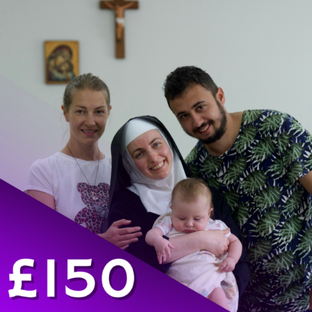
Despite having limited resources, the Sisters in Hoshiv have welcomed hundreds of refugees through their convent doors since the start of the war in Ukraine. They are currently providing shelter for 76 people from the country’s war-torn regions. However, with more support from ACN, the Sisters believe they can make room for up to 160 people by turning their conference facilities and classrooms into bedrooms.
Could you fill your Maisy carton to the value of £150?
Please support these faithful Sisters in Ukraine and other troubled parts of the world, as they offer hospitality, shelter and prayers for healing.

Maisy Milk Rosary for Peace – Thursday: The Presentation of Jesus in the Temple
Praying for families and the elderly affected by war in Syria.
The Presentation: Luke 2:22-38
When the time came for the purification rites required by the Law of Moses, Joseph and Mary took him to Jerusalem to present him to the Lord (as it is written in the Law of the Lord, “Every firstborn male is to be consecrated to the Lord”), and to offer a sacrifice in keeping with what is said in the Law of the Lord: “a pair of doves or two young pigeons.”
Now there was a man in Jerusalem called Simeon, who was righteous and devout. He was waiting for the consolation of Israel, and the Holy Spirit was on him. It had been revealed to him by the Holy Spirit that he would not die before he had seen the Lord’s Messiah. Moved by the Spirit, he went into the temple courts. When the parents brought in the child Jesus to do for him what the custom of the Law required, Simeon took him in his arms and praised God, saying:

“Sovereign Lord, as you have promised,
you may now dismiss your servant in peace.
For my eyes have seen your salvation,
which you have prepared in the sight of all nations: a light for revelation to the Gentiles,
and the glory of your people Israel.”
The child’s father and mother marvelled at what was said about him. Then Simeon blessed them and said to Mary, his mother: “This child is destined to cause the falling and rising of many in Israel, and to be a sign that will be spoken against, so that the thoughts of many hearts will be revealed. And a sword will pierce your own soul too.”
There was also a prophet, Anna, the daughter of Penuel, of the tribe of Asher. She was very old; she had lived with her husband seven years after her marriage, and then was a widow until she was eighty-four. She never left the temple but worshiped night and day, fasting and praying. Coming up to them at that very moment, she gave thanks to God and spoke about the child to all who were looking forward to the redemption of Jerusalem.
Reflection through the eyes of Mary
As a Jewish family, we know that children are a gift from God and to show we understood this, we would bring them to the temple to present them back to God with a sacrifice. When we got there, we met Simeon and Anna. The Holy Spirit had told them that Jesus is “God’s Salvation.” God chooses people that he reveals his plans to - not the powerful people, but the faithful, whose prayers have more power than all the armies in the world. I am honoured to be chosen by God, and Simeon and Anna felt the same. Simeon knew that meeting Jesus was the most important thing that happened in his life - I hope people in the future feel the same.

Prayer Intention
God our Father, you have plans for all of us, for peace and not disaster. Let your Kingdom come to all the places in the world where there is war, fighting and division. Melt away anything which causes us to distrust each other and may all people come to the understanding that meeting your son, Jesus, is more important than anything else. We pray for the families in Syria who have had to flee their homes and the elderly who rely on the Church to survive. Help ACN to be able to continue serving those who suffer.

Fundraising with Maisy Milk

In a very poor district of Syria’s capital Damascus, the Melkite Greek Catholic parish of St Youssef has a centre run by eight Christian staff. With funding from ACN, the parish has set up a project to provide hot meals for 300 of the most vulnerable and elderly people – identified through the Church’s pastoral work in the neighbourhood. Meals will be delivered three times a week to the housebound.
Could you put £12 into your Maisy Milk bottle?

Your gift will feed the elderly and vulnerable and help them feel part of God’s family.

Maisy Milk Rosary for Peace – Friday: The Finding of Jesus in the Temple
Praying for peace in the Holy Land.

Every year his parents used to go to Jerusalem for the feast of Passover. And when Jesus was twelve years old, they made the journey as usual for the feast. When the days of the feast were over and they set off for home, the boy Jesus stayed behind in Jerusalem. His parents were not aware of this. Assuming that he was somewhere in the group of travellers, they journeyed for a day. Then they started to look for him among their relatives and friends, but when they failed to find him, they returned to Jerusalem to search for him.

After three days they found him in the temple, where he was sitting among the teachers, listening to them and asking them questions. And all who heard him were amazed at his intelligence and his answers. When they saw him, they were astonished, and his mother said to him: “Son, why have you done this to us? Your father and I have been searching for you with great anxiety.” Jesus said to them, “Why were you searching for me? Did you not know that I must be in my Father’s house?” But they did not comprehend what he said to them.
(New Catholic Bible)

Reflection through the eyes of Mary
It was so busy in Jerusalem for the Passover and the first time Jesus, now over twelve, could take his place within the community as a young man. We knew Jesus had a mission, but it was still a shock when we saw this glimpse of what was to come and even though I knew what the Angel Gabriel had said about him, we still did the normal thing families do. That was why I was so worried when he was lost. Jesus would never disobey us... there was something far bigger happening. It was so joyful to find him after three days... little did I know how significant three days would be in the future...

Prayer Intention
We pray for peace. Lord Jesus, please change the hearts of those who believe that war and fighting is their only option. We ask for reconciliation for people on all sides of the dispute, for unity and for greater understanding. Please help those who have no food because of the war.
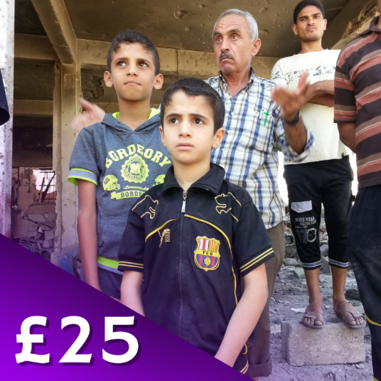
Fundraising with Maisy Milk
Christians living in the Holy Land have been caught up in the deepening crisis which has engulfed the region. The war has resulted in a humanitarian catastrophe, which has plunged the Christian community into poverty. ACN is working with Church partners on the ground to provide hot meals for the hungry. Your generous gift of £25 could provide hot meals for desperate families in the Holy Land.

Could you encourage your family to raise £25 to provide hot meals for families in the Holy Land?

