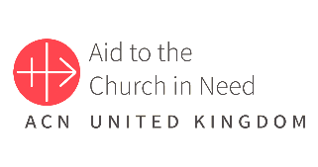Aid to the Church in Need

‘One Million Children Praying the Rosary’ Support Document

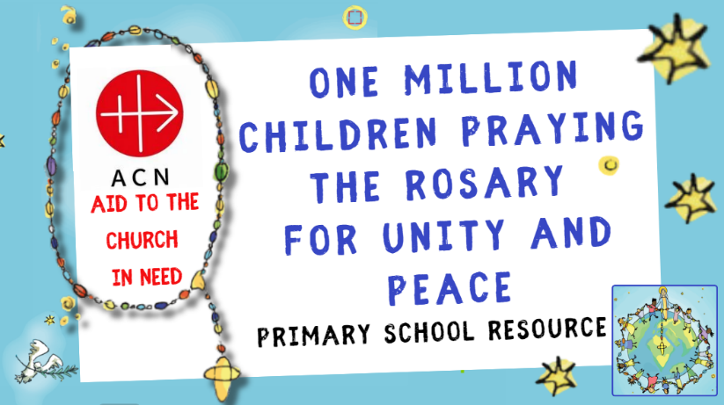 ‘The Rosary is a prayer that always accompanies me; it is also the prayer of the ordinary people and the saints … it is a prayer   
from my heart.’

Pope Francis

One Million Children Praying the Rosary for Unity and Peace (2024)  
This resource has been produced to support this year’s ‘One Million Children Praying the Rosary for Unity and Peace’ campaign. Through taking part in this campaign/using this presentation, children will gain an insight into the work of Aid to the Church in Need (ACN) and understand its unique identity/contribution as the only international Catholic organisation focusing on the pastoral and spiritual support of persecuted and suffering Christians.

The presentation is structured as follows:

Slides 1 – 6: General introduction to the ‘One Million Children Praying the Rosary’ campaign.

Slides 7 – 14: Focus on the history/work of ‘Aid to the Church in Need’ (ACN) supporting persecuted Christian communities throughout the world.

Slides 15 – 33: Introduction to the ‘One Million Children Praying the Rosary’ campaign (including promotional video on slide 16) and information about the Rosary, including some ‘Fun Facts’.

Slides 34 – 43: Overview of the Mysteries of the Rosary.

Slides 44 – 70: Sorrowful Mysteries reflection.

Slides 71 – 78: Reflection on the transformative power of the Rosary; thank you.

This presentation could be used in a variety of ways, including:

* Whole school/phase assemblies to introduce the work of ACN and subsequently take part in the ‘One Million Children Praying the Rosary’ campaign.
* In individual classes as above.
* As a resource for your Chaplaincy Team/RE Team/Mini Vinnies to promote the work of ACN and the ‘One Million Children Praying the Rosary’ campaign.

NB: Quiet music has been included during the Sorrowful Mysteries (slides 50 – 52; 55 – 57; 60 – 62; 65 – 67 and 70 – 72) to support reflection; this can be muted at the discretion of individual schools/leaders. As part of their reflection, children could be given the opportunity to colour/draw their own representations of each mystery; click here for some examples.

Aims

* To provide children with the opportunity to participate in ACN’s ‘One Million Children Praying the Rosary for Unity and Peace’ Campaign.
* To develop the children’s understanding of the importance of the Rosary in Catholic belief.
* To help children understand how to pray the Rosary and meditate on the various mysteries, especially the ‘Sorrowful Mysteries’.
* To provide the children with an insight into the transformative power of the Rosary.
* To help children to understand that the Rosary can be used for personal and community prayer.
* To develop the children’s understanding of the work of ACN to support poor and vulnerable Christian communities around the world.
* Engage with fundraising and/or prayer to support the work of ACN.

Catholic Self-Evaluation Document (CSED) - Evidence   
Through using this resource, school leaders will be able to provide evidence to support judgements in the following aspects of the Catholic Self-Evaluation Document (CSED):

Catholic Life and Mission (CLM)

CLM 1.3 Moral Development  
CLM 1.4 Catholic Social Teaching  
CLM 1.5 Respect for Self and Others  
CLM 3.5 Commitment to Catholic Social Teaching

Religious Education (RE)

RE1.1 Development of Knowledge, Understanding and Skills  
RE 1.3 Religious Literacy  
RE 2.6 Spiritual and Moral Development  
RE 3.7 Enrichment

Collective Worship (CW)

CW1.4 Influence of Curriculum and School Life  
CW 1.5 Impact  
CW 2.1 Centrality  
CW 2.4 Use of scripture

‘To Love You More Dearly’ – The Prayer and Liturgy Directory

Devotions

‘The Catholic Church has a rich history and tradition of devotions. Many are associated with times of the year, such as praying for those who have died in the month of November.

Other devotions are linked with Our Lady, including the months of October and May. These may be marked by the praying of the Rosary or other Marian devotions such as processions.’ (p35)

Many devotions relate to the liturgical year. Their purpose is to provide times of prayer which often  
draw on all the senses and lead us back to the liturgy with a deeper prayerful understanding of what we celebrate. (p46)

Presentation Overview/Notes

|  |  |
| --- | --- |
| Slides 1 - 6 | General introduction to the ‘One Million Children Praying the Rosary for Unity and Peace’ campaign (18th October); if children have taken part in this initiative before, this can be discussed/celebrated. |
| Slides 7 - 12 | Introduction to the work of Aid to the Church in Need (ACN); slide 8 provides a narrated overview of the work of ACN. Insight into some of the numerous projects to support persecuted Christian communities throughout the world is provided in a short presentation on slide 10. Slide 12 provides a link to the ‘One Million Children Praying the Rosary’ campaign through the power of prayer. |
| Slides 13 - 16 | Introduction to this year’s ‘One Million Children Praying the Rosary for Unity and Peace’ campaign; slide 16 – promotional video. |
| Slide 17 | ‘The Rosary is a prayer that always accompanies me; it is also the prayer of the ordinary people and the saints … it is a prayer from my heart.’  Q: What does this quote from Pope Francis tell you about the importance/power of the Rosary in our daily lives? |
| Slides 18 - 27 | Some Fun and Fascinating Rosary Facts; slide 27 introduces the idea of ‘meditation’ – this can be explored with the children at an appropriate level. |
| Slides 28 - 31 | Focus on the various ‘mysteries’ of the Rosary, including the introduction of the fourth set of ‘Luminous Mysteries/The Mysteries of Light’ by Pope John Paul II in 2002. Pope John Paul II also suggested which mysteries should be said on different days of the week; hence, this year’s ‘One Million Children Praying the Rosary for Unity and Peace’ campaign will focus on the ‘Sorrowful Mysteries’ since 18th October is on a Friday. |
| Slides 32 - 33 | Rosary Prayers: The prayers included in a decade of the Rosary are outlined. For a ‘full set’ of Rosary Prayers, including the Apostles Creed and the Fatima Prayer, click here. |
| Slides 34 - 43 | Overview of the various mysteries of the Rosary as follows:   * Joyful Mysteries * Sorrowful Mysteries * The Luminous Mysteries * The Glorious Mysteries   Remind the children that we will be focusing on the ‘Sorrowful Mysteries’. |
| Slides 44 - 46 | Invitation to take part in this year’s ‘One Million Children Praying the Rosary for Unity and Peace’ campaign. |
| Slides 47 - 73 | Praying the Rosary – The Sorrowful Mysteries*.  Each mystery (see below) is presented as an image initially which is then accompanied by a commentary/guided reflection and is concluded with a prayer. Reflective music accompanies each mystery; this can be muted if preferred.  The reflections/prayers are contained in the ‘One Million Children Praying the Rosary for Unity and Peace’ booklet.  1. The Agony in the Garden - Luke 22:39-44  2. The Scourging at the Pillar - Matthew 27:26  3. The Crowning with Thorns - Matthew 27:28-31  4. The Carrying of the Cross - Luke 23:26-32  5. The Crucifixion - Matthew 27:33-50  (*Depending on the age of the children, you may wish to focus on a particular mystery and provide your own commentary/reflection whilst simply looking at the image provided.) |
| Slide 74 | Children’s Consecration to Our Lady. |
| Slides 75 - 76 | The Power of the Rosary.  Slide 76: Maria and Matthew share their thoughts on the Rosary. |
| Slides 77 - 78 | Q: Have you enjoyed taking part in today’s rosary session?  Q: Would you like to pray the rosary more often after today’s session? |
| Slide 79 | ‘Reciting the Rosary is “the most important appointment of the day.”’ - Blessed Carlo Acutis; this quote could be discussed with the children at an age-appropriate level. |
| Slides 80 - 82 | ‘Thank You’ from ACN. |

Fundraising for ACN

ACN is always grateful for the funds raised for its projects. Please note that the projects mentioned in this presentation are an example of its work. Your funding may go to these or similar projects.

Thank you for all that you do to support the work of ACN, both in your fundraising and in your prayers which are equally important.

Please let us know how you have raised funds via

* Twitter (X): @acn_uk
* Instagram: @aidtothechurchinneed_uk

ACN - October 2024