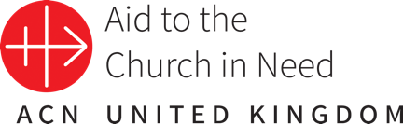Aid to the Church in Need

Advent Prayer Resource 2024

Teacher Support Document

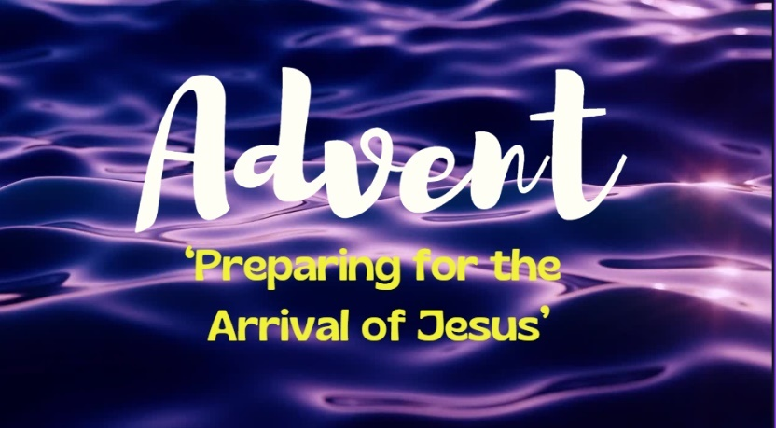

‘Be on guard, keep awake. For you do not know when the time will come.’

Mark 13:33

Aims

Through using this ‘Advent Prayer Resource’, pupils will be able to:

* Develop a deeper understanding of the work of ACN to support poor and vulnerable Christian communities around the world, including through the ‘Gifts of Faith’ initiative.
* Develop a deeper understanding of the season of Advent and its significance within the Liturgical Year.
* Understand that Advent is a time to prepare our hearts and minds to celebrate the arrival of Jesus at Christmas.
* Learn about/consolidate their understanding of the symbolism of the Advent wreath.
* Reflect on the different themes of Advent (Hope, Peace, Joy and Peace) and understand how they help us to prepare fully to celebrate the birth of Jesus.
* Participate in meaningful prayer and reflection on the various themes of Advent.
* Engage with fundraising and/or prayer to support the work of ACN.

Catholic Self-Evaluation Document - Evidence

Through using this resource, school leaders will be able to provide evidence to support judgements in the following aspects of the Catholic Self-Evaluation Document (CSED):

Catholic Life and Mission (CLM)

CLM 1.3 Moral Development

CLM 1.4 Catholic Social Teaching

CLM 1.5 Respect for Self and Others

CLM 3.7 The Catholic Curriculum

Religious Education (RE)

RE 1.3 Religious Literacy

RE 2.6 Spiritual and Moral Development

RE 3.1 RED

RE 3.7 Enrichment

Collective Worship (CW)

CW1.1 Engagement & participation

CW1.2 Variety and liturgical year

CW1.4 Influence of Curriculum and School Life

CW 1.5 Impact

CW 2.1 Centrality

CW3.3 Sacraments, Holy Days of Obligation and other significant days

CW 3.6 Impact of Leadership

CW3.7 Resourcing

‘To Know You More Clearly’: The Religious Education Directory (RED)

Whilst this is primarily a prayer resource, various elements of the RED, particularly in relation to the different ‘Knowledge Lenses’ and the ‘Ways of Knowing’ (Discern and Respond), can be readily addressed through providing pupils with the opportunity to participate in the various reflections contained therein.

Knowledge Lenses – End of Phase Expected Outcomes

The RED identifies six knowledge lenses which detail what should be known by the end of each age-phase. This resource can support teachers in helping to evidence expected outcomes in the Hear, Believe, Celebrate and Live knowledge lenses.

Ways of Knowing

The RED identifies three ‘ways of knowing’ in its Programme of Study that enable skills to be developed at an appropriate level. The development of these aspects allows each knowledge lens to be explored appropriately. The ways of knowing are Understand (U), Discern (D) and Respond (R).

End of phase Age-Related Expectations, that could be linked to this ‘Advent Prayer Resource’ are listed below.

Age 5 - 7

U1.6.2. Recognise that Catholics are a part of a global Christian family, and all Christians are sisters and brothers.

U1.4.2. Recognise that Jesus shows the importance of giving to others,

U2.6.2. Describe an initiative Christians work on together locally and/or globally in the service of others.

R1.3.2. Reflecting on how Jesus is a ‘light’ for all people and consider how they can bring ‘light’ to their families and communities.

Age 7 - 9

D3.1.2. Thinking about how all people should be treated equally.

R.4.4.1. Reflecting on how the life and work of a person or organisation (historical or contemporary) lives out the works of mercy and/or the love for those oppressed by poverty and the inspiration they offer for their life.

R.4.5.3. Reflecting on how Christian communities continue the work of Jesus in the community where they live.

Age 9 – 11

R5.3.4. Reflecting on how the communities they are part of could be transformed if everyone chose to love their neighbour as themselves.

R6.4.2. Considering how love of neighbour could transform their life and the lives of the communities they are part of, describing the actions they could take to begin this transformation.

R6.5.3. Reflecting on how the work of charities can support people facing injustice or persecution.

Presentation Overview/Notes

If children are unfamiliar with ‘Aid to the Church in Need’ you may wish to introduce the abbreviation ‘ACN’ and explain that its work (including the ‘Gifts of Faith’ initiative) will be explored in further detail during the presentation. Explain that ACN is currently working on over five thousand projects in over one hundred and forty countries all around the world, helping to support the Church in its mission, and bringing hope and solidarity to millions of persecuted Christians; the donations received from benefactors/supporters enable ACN to help persecuted and suffering Christians live out their faith as fully as possible.

Further information can be found on the ACN website, particularly in the Primary Resources section: <https://acnuk.org/resources/?filter_resource_category=255>

|  |  |
| --- | --- |
| Slides 1 - 2 | Opening Slides: Musical accompaniment.  Slide 1 – Title Slide: Advent - ‘Preparing for the Arrival of Jesus’.  Q: What do you already know about the season of Advent?  Pupils to share their understanding/knowledge; explore as appropriate.  Slide 2: ‘Be on guard, keep awake. For you do not know when the time will come.’ (Mark 13:33)  Q: What do you think that Mark is referring to in this quote? |
| Slides 3 - 4 | Slide 3: ‘Advent is a time to prepare our hearts and minds to celebrate the arrival of Jesus at Christmas.’  Q: Why do you think is important to prepare for Jesus’ birth?  Slide 4: Explanation of the Latin derivation of Advent; from the Latin ‘ad + venire,’ which means, ‘to come to’ or ‘to come toward.’  ‘Ad + venire’ is the root of the Latin ‘adventus’ which means ‘arrival.’ |
| Slides 5 - 6 | Slide 5: Brief introduction to the work of Aid to the Church in Need (ACN) – see pre-presentation notes. Explain that this Advent, ACN is inviting you to join us in our very own prayer journey across the world as we turn our thoughts to some of the many communities that we support in different countries across the globe.  Slide 6: Introduction the weekly themes of Advent; this is explored further on the following slides. |
| Slides 8 - 11 | Introduction to the weekly themes: Hope; Peace; Joy; Love.  Q: Why do you think that we focus on these themes during Advent?  Q: Do you think that one theme is more/most important; why? |
| Slides 12 - 13 | Explain that during each week of Advent, we will be focusing our prayer intentions on one country (out of over 140!) supported by ACN linked to the different themes outlined in the previous slides; these countries are as follows:   * Nigeria - Hope * Lebanon - Peace * Brazil - Joy * Ukraine – Love   Explain that whilst we are focusing on one country for each week of Advent, the children will also be praying for all of the countries/communities throughout the world supported by ACN. You could explore children’s knowledge of these countries at this point (alternatively, this could be done prior to/during the different focus weeks); of course, you will need to be sensitive to the needs of any children in your class with family connections to any of these countries. |
| Slide 14 | Explain that each of the focus countries/projects are part of ACN’s current fundraising initiative, ‘Gifts of Faith’.  More information can be found on the ACN website: <https://acnuk.org/our-campaigns/gifts-of-faith/> |
| Slides 15 - 22 | Week 1 – Hope: Focus country – Nigeria.  Slide 16: Introduce the ‘Prophet’s Candle’ which reminds us that Jesus is our Saviour and that we await his coming with hope and anticipation during the Advent season.  Q: What does the word ‘prophet’ mean; what is a prophecy?  Slide 17: Nigeria focus - ACN is working with Bishop Wilfred Anagbe to provide full scholarships for children to enable them to attend school and break free from poverty and despair.  Q: Why is education so important for the children that ACN supports?  Slides 18 - 22: Reflection/Prayers: The prayers on slides 19 and 22 are repeated each week; the first prayer [(slide 19 – Fr. Henri JM Nouwen) could be shared between the class or the teacher/class as appropriate; similarly, for the ‘Advent Prayer (slide 22)]. Children could also be encouraged to use spontaneous prayer during these reflections; teachers may also wish to adapt the reflection through adding their own/children’s prepared prayers.  Teachers could also assign a group of children to lead (at an age-appropriate level) the reflection each week. |
| Slides 23 - 30 | Week 2 – Peace: Focus country – Lebanon.  Slide 24: Introduce the ‘Bethlehem Candle’ which reminds us of the journey that Mary and Joseph went undertook from Nazareth to prepare for the birth  of Jesus and his ‘Kingdom of Peace’.  Slide 25: Lebanon focus - The conflict in southern Lebanon has forced many Christian families to flee their homes; but many have remained, trying to survive in desperate conditions without basic necessities like food. ACN has responded by distributing essential food parcels to hungry families.  Q: Why do you think that some people have stayed in their homes despite the terrible conditions that they are being forced to live in?  Q: How would you feel if you were forced to leave your home?  Prayer and Reflection: See slides 18 – 22. |
| Slides 31 - 39 | Week 3 – Joy: Focus country – Brazil.  Slide 32: Explain that the rose (pink) vestments worn by the priest on the third Sunday of Advent are also the colour of the ‘Shepherd’s Candle’. Both symbolise the world’s joy for the long-expected Saviour’s birth.  Q: The shepherds were the first people to visit the newborn king; why do you think this was?  Slide 33: Brazil focus – Whilst we are focusing on Brazil, explain that the ACN Child’s Bible has been translated into 194 languages and shared over 51.7 million times in the last 44 years.  Q: Why do you think that these Bibles are so special to these children?  Q: What does this tell us about our ‘relationship’ with the Bible?  Prayer and Reflection: See slides 18 – 22. |
| Slides 40 - 48 | Week 4 – Love: Focus country – Ukraine.  Slide 41: ‘And in the end, everything else will turn out to be unimportant and inessential, except for this: Father, Child, and Love.’ St. (Pope) John Paul II.  Q: What does this quote from St. (Pope) John Paull II tell us about ‘love’?  Slide 42: Explain that the love that our Divine Saviour, Jesus, brings is celebrated on the fourth Sunday of Advent by the ‘Angel’s Candle’ which reminds us ff the infinite love that God has for each of us.  Q: What does infinite mean?  Q: What else on the Advent wreath symbolises God’s infinite love for us?  Slide 43: Ukraine focus - ACN is responding to the urgent needs of families affected by the conflict in Ukraine. These families have nowhere to return to, as their homes have been destroyed. ACN is helping to sustain these vulnerable families, offering hope and the chance to rebuild their lives.  Q: What does it mean to be ‘vulnerable’?  Q: Why should we support anyone who is ‘vulnerable’?  Prayer and Reflection: See slides 18 – 22. |
| Slide 49 | ‘Gifts of Faith’ reminder – Invitation to donate to ACN; could your class/school support one of the communities featured during our prayer journey through Advent? Click on the following link for further information: <https://acnuk.org/our-campaigns/gifts-of-faith/> |
| Slide 50 | Closing Slide – Thank You. |

Fundraising for ACN

ACN is always grateful for the funds raised for its projects; please note that the projects mentioned in this presentation are an example of ACN’s work. Your funding may go to these or similar projects.

Thank you for all that you do to support the work of ACN, both in your fundraising and in your prayers which are equally important.